UNIVERSIDAD EUROPEA DE MADRID

FLUID MECHANICS II

HOMEWORK 5

***Problem 1***

Investigate the velocity potential φ = Kxy, K = constant. Sketch the potential lines in the full xy plane, find any stagnation points, and sketch in by eye the orthogonal streamlines. What could the flow represent?

***Problem 2***

An incompressible stream function is defined by



where U and L are (positive) constants. Where are the streamlines of this flow plotted? Use this stream function to find the volume flow Q passing through the figure rectangular surface whose corners are defined by (x, y, z) = (2L, 0, 0), (2L, 0, b), (0, L, b), and (0, L, 0). Show the direction of Q.



***Problem 3***

A two-dimensional incompressible flow field is defined by the velocity components

$u= {yx}^{2}-y^{2}$ and $v= -xy^{2}$

If they exist, find the stream function and velocity potential.

***Problem 4***

Consider the two-dimensional incompressible velocity potential φ = 4xy - x2 + y2. (a) Is it true that ∇2φ = 0, and, if so, what does this mean? (b) If it exists, find the stream function ψ(x, y) of this flow. (c) Find the equation of the streamline which passes through (x, y) = (2, 1).

***Problem 5***

Air flows at 2m/s along a flat wall when it meets a jet of air issuing from a slot at A. The jet volume flow is 4m3/s per unit of width into the paper. If the jet is approximated as a line source, (a) locate the stagnation point S. (b) How far vertically will the jet flow extend?

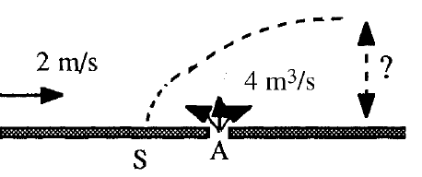

***Problem 6***

A very wide NACA 4412 airfoil, with a chord of 150cm, is tested in a sea-level wind tunnel at 10m/s and found to have a lift of 20lbf per foot of span. Estimate the angle of attack for this condition.

Table. Zero-Lift Angle of NACA Airfoils



***Problem 7***

Two-dimensional lift-drag data for the NACA 2412 airfoil with 2 percent camber may be curve-fitted accurately as follows:





with α in degrees in the range –4° < α < +10°. Compare (a) the lift-curve slope and (b) the angle of zero lift with theory, .CL=2ᴨ sin (α+β) (c) Prepare a polar lift-drag plot.